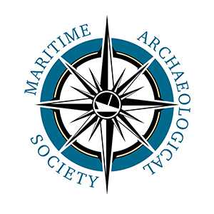
I want to support the Maritime Archaeological Society
My Donation amount is: ___________
I am Paying By:  Check   Cash
Note (if needed) _________________________________________
OR
   I am making an in-kind donation
*contact us to make arrangements and list item(s) on a separate page
Your Name: __________________________________________________
Signature: ___________________________________________________
Address:____________________________________________________
City: ___________________________ Postal Code: _________________
 Please send me a receipt
 Check here if you do not wish your donation to be acknowledged publicly.
Please send your donation to:
Maritime Archaeological Society P.O. Box 332 Astoria, OR 97103
Thank you.
The Maritime Archaeological Society - MAS - is a registered 501(c)(3) not for profit organization. Your contribution may be tax deductible.
If you wish to become a member of MAS, please use the Membership Form on our website to sign our Ethics statement. You will then be able receive our member newsletter and other benefits.

