Please direct media inquiries to Alyssa Messenger: amessenger@rowman.com

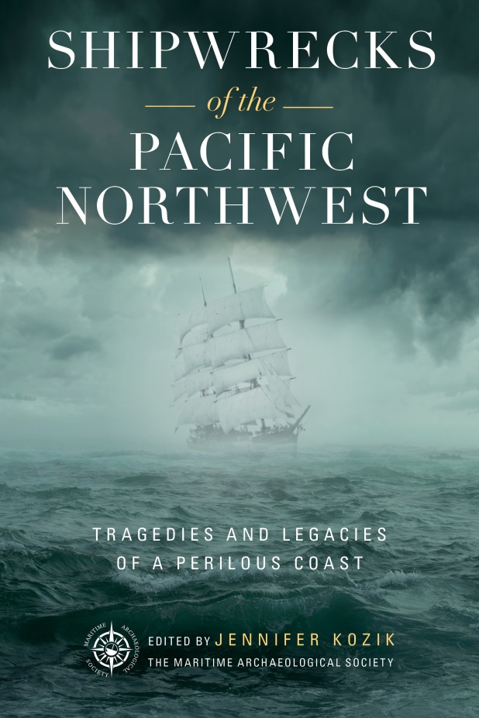
Shipwrecks of the Pacific Northwest:
Tragedies and Legacies of a Perilous Coast

Edited by Jennifer Kozik

9781493044535 • Hardback • March 2020
$26.95 • 256 pages

Over the past 350 years, an untold number of ships have met their end along the northern Oregon and southern Washington coasts. Shipwrecks of the Pacific Northwest investigates some of the most compelling historic shipwrecks—from the infamous to the nearly forgotten. Explore a handful of these vessels, fated to have their final resting place along 150 miles of the rugged Northwest coastline, including near the dangerous mouth of the Columbia River. Combining archaeological analysis and new research, this unique collection uncovers the tales of peril, tragedy, and heroism along with the tangible legacies and an exploration of what remains.

About the Editor and Co-Author

Jennifer Kozik has a B.A. in Anthropology from the University of Missouri and a background in non-profit outreach. She previously worked with the Washington County Museum as Collections & Exhibits Manager/Public Programs Manager. Jennifer has written numerous successful grants and has served as a peer review panelist for the NEH Division of Preservation and Access. By day, Jennifer works as a Training and Support Specialist with the Technology departments at the stop-motion film company LAIKA. She also shares a life-long passion for history and being near the sea.

The authors are available for interview, signings, and media engagements.
Please direct media inquiries to Alyssa Messenger: amessenger@rowman.com

